NET731 FA3 WEEK 1
NHLANHLA J NKOSI
20232271

TASK 1-
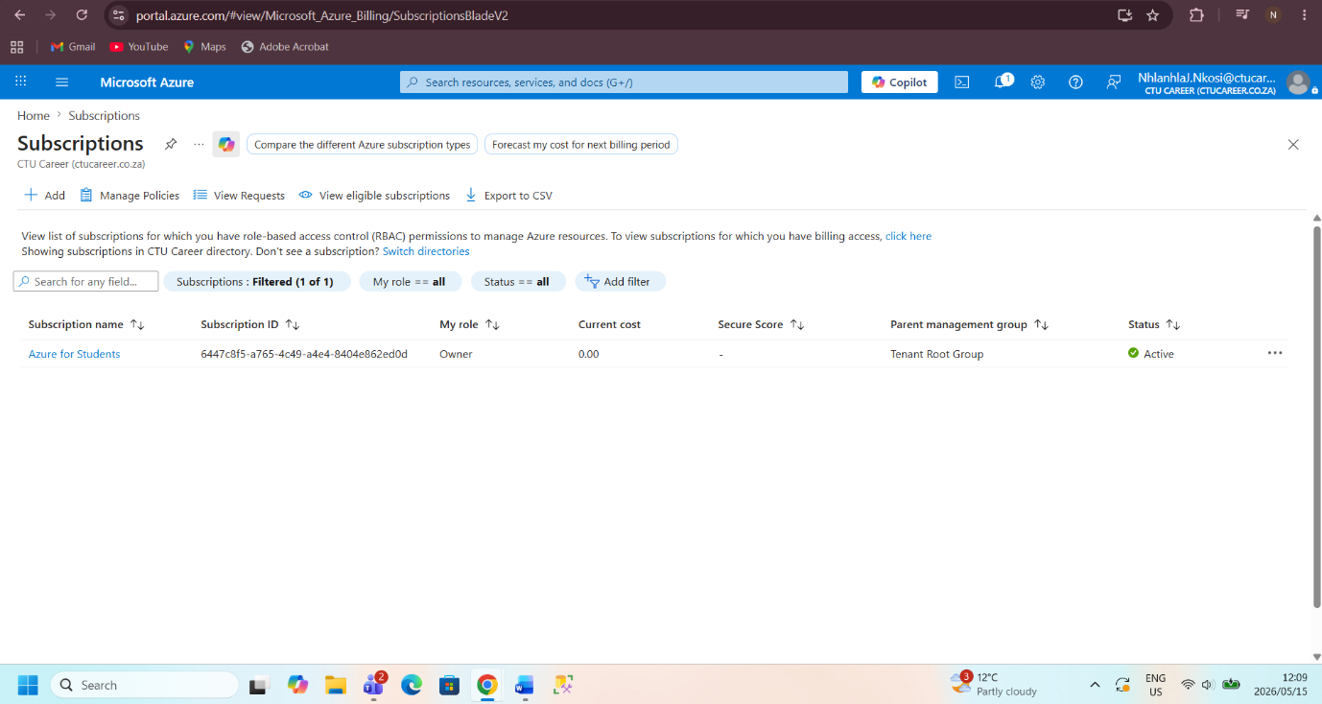

TASK 2-
CTU Training Solutions offers professional certifications, diploma programs, and vocational training in a number of subjects, including information technology, engineering, business, and design. The organization facilitates both in-person and virtual learning and runs several campuses. A dependable, scalable, and secure IT infrastructure that can effectively support students, instructors, administrators, and business operations is becoming more and more necessary as the school grows
CTU Training Solutions is a medium-sized educational company that works in South Africa's higher education and training sector. The organization's primary goal is to prepare students for future jobs by offering them industry-focused training, practical skill development, and high-quality education.
For daily operations to run smoothly, CTU Training Solutions needs a number of crucial IT services and systems. For the safe storage of student records, assessments, financial data, and administrative documents, dependable cloud storage and database administration are essential.

Additionally, the organization needs secure identification and access control solutions for instructors, administrators, and students. This keeps sensitive data safe from unauthorized access while enabling authorized users to safely access systems and apps.
There are a number of benefits to using Microsoft Azure over conventional on-premises infrastructure. Scalability is one of the most significant benefits. Azure enables CTU to adjust its computer capacity based on user numbers and workload demands. This is especially helpful during busy times like when students are registering, taking tests, and turning in assignments.
All information systems must adhere to regulatory regulations and security standards, according to CTU Training Solutions. Financial data and student records are examples of sensitive information that has to be shielded from cyberattacks and illegal access.
Therefore, the cloud infrastructure needs to be scalable enough to accommodate several users at once during busy times like online tests and virtual classes. Azure can manage varying workloads while preserving system speed thanks to its scalability capabilities.

REFERENCES
Microsoft. 2026. Microsoft Azure Documentation. Available at:
Microsoft Azure Documentation
[Accessed 01 May 2026].
Microsoft. 2026. What is Cloud Computing?. Available at:
Microsoft Azure Cloud Computing Guide
[Accessed 01May 2026].
Republic of South Africa. 2013. Protection of Personal Information Act (POPIA). Available at:
POPIA Act South Africa
[Accessed 01 May 2026].
CTU Training Solutions Official Website
2026. About CTU Training Solutions. [Accessed 01May 2026].
Microsoft Security Documentation
2026. Cloud Security Best Practices. [Accessed 01 May 2026].

